DCN – LAB 06

10/30/2022

MUHAMMAD NOMAN – 35152- BSCS

SUBMITTED TO   MA’AM MARIYA HANIF

**CLASS ACTIVITY: EMAIL SERVER CONFIGURATION…**

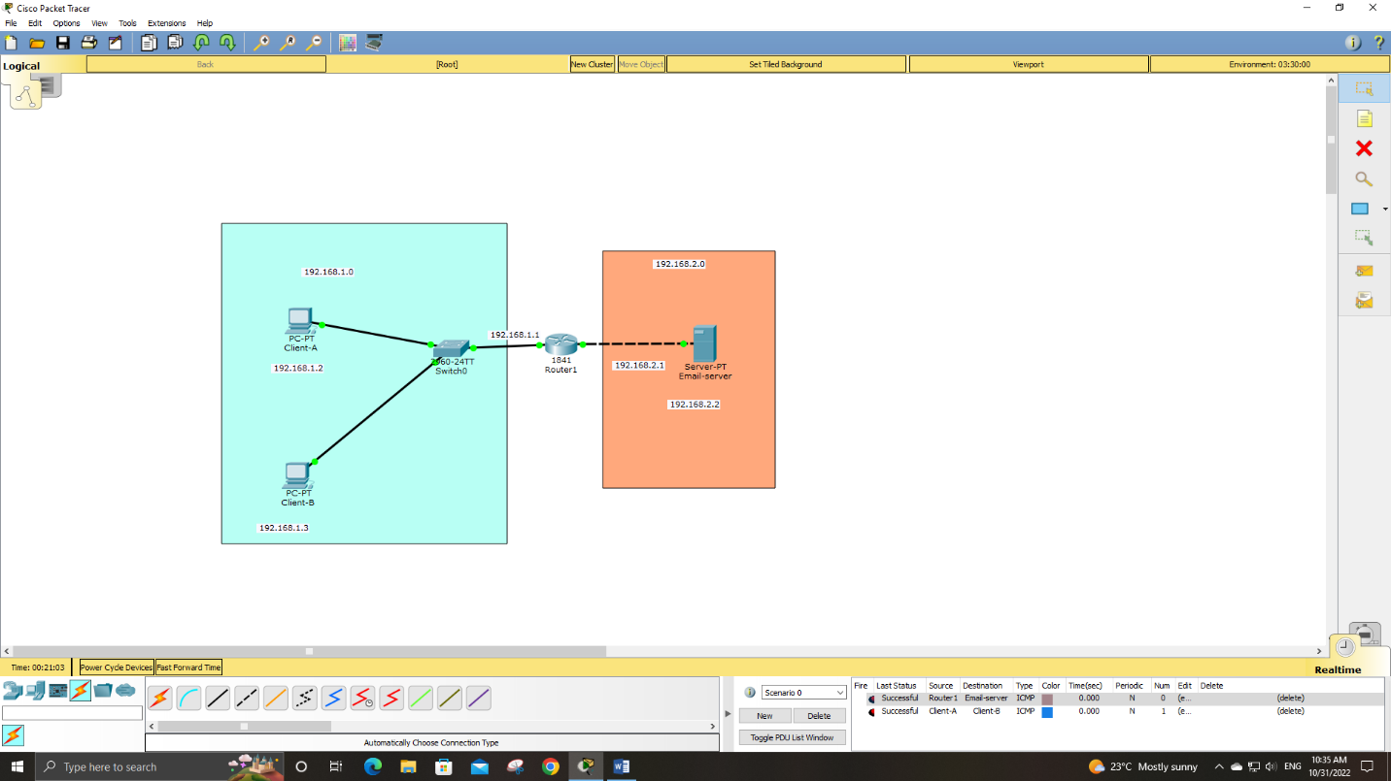



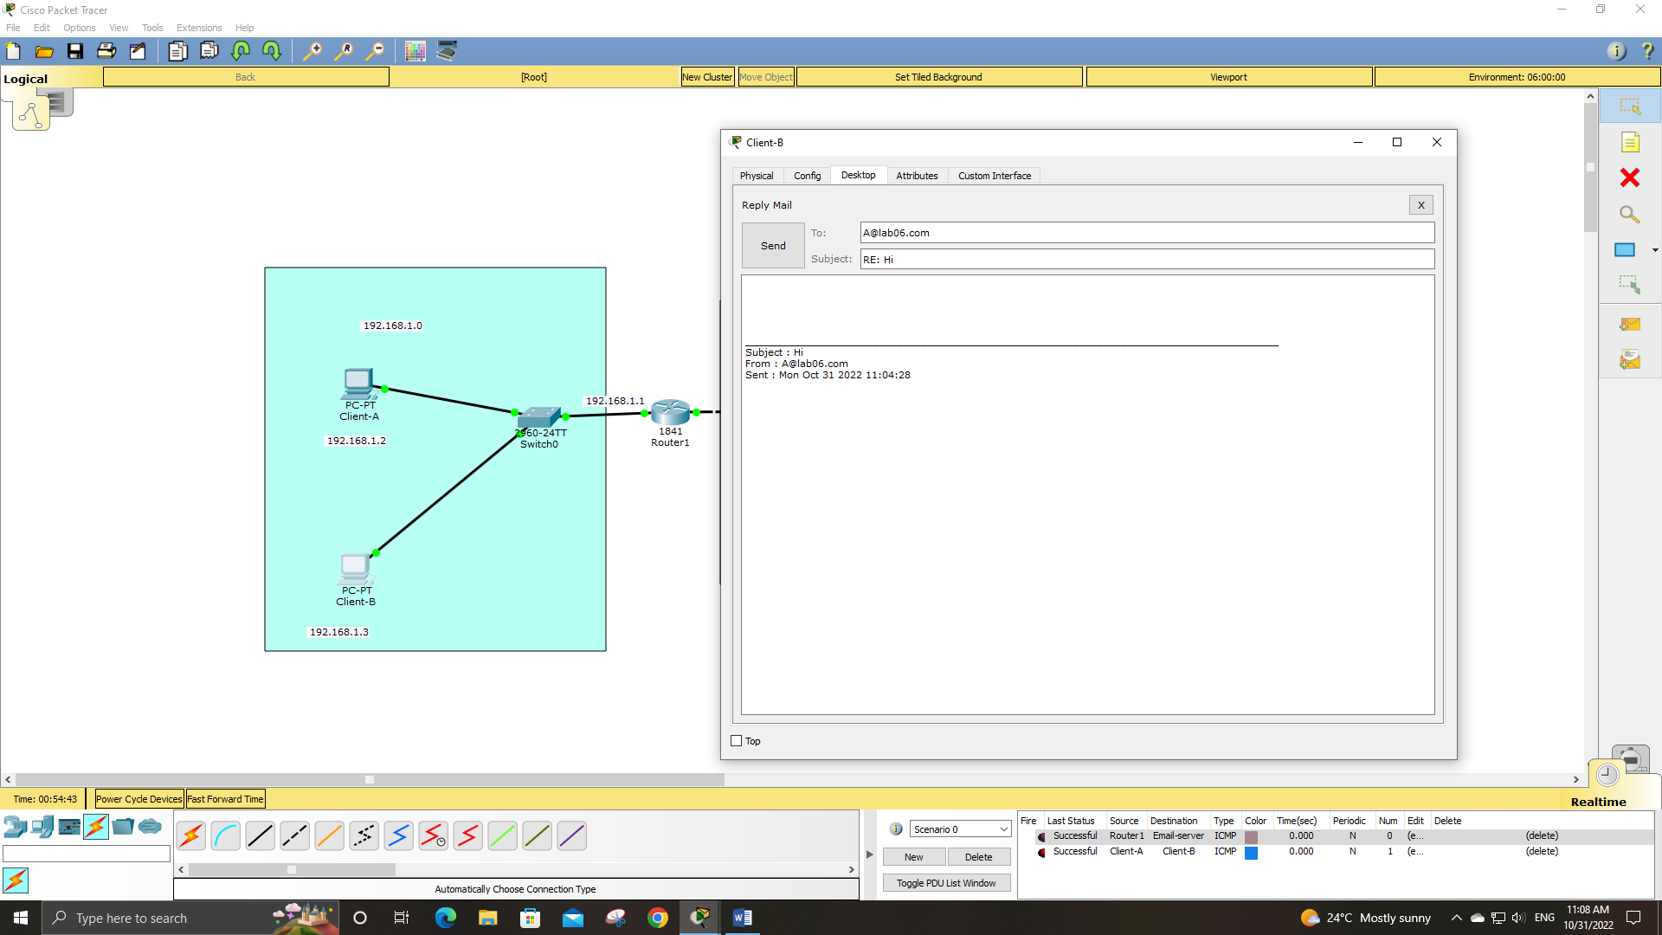

**LAB TASK # 5:**

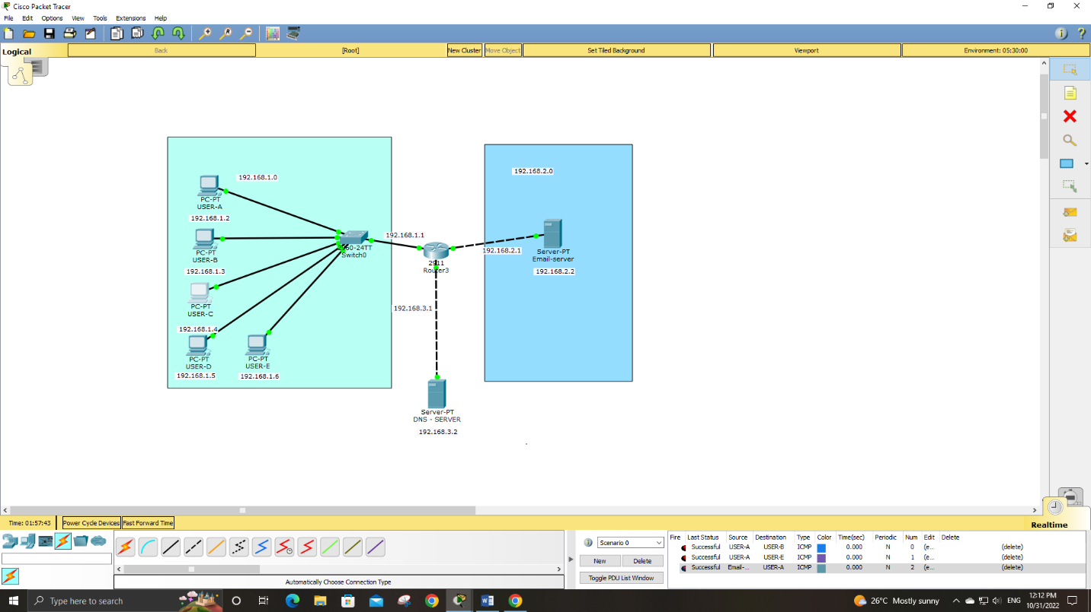

**PC AND ROUTER CONFIG:**

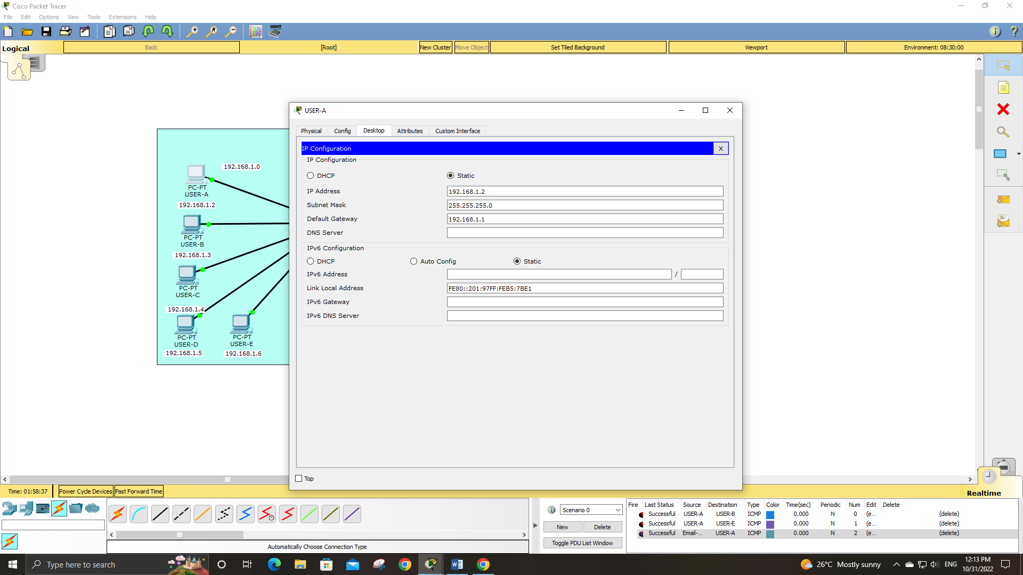

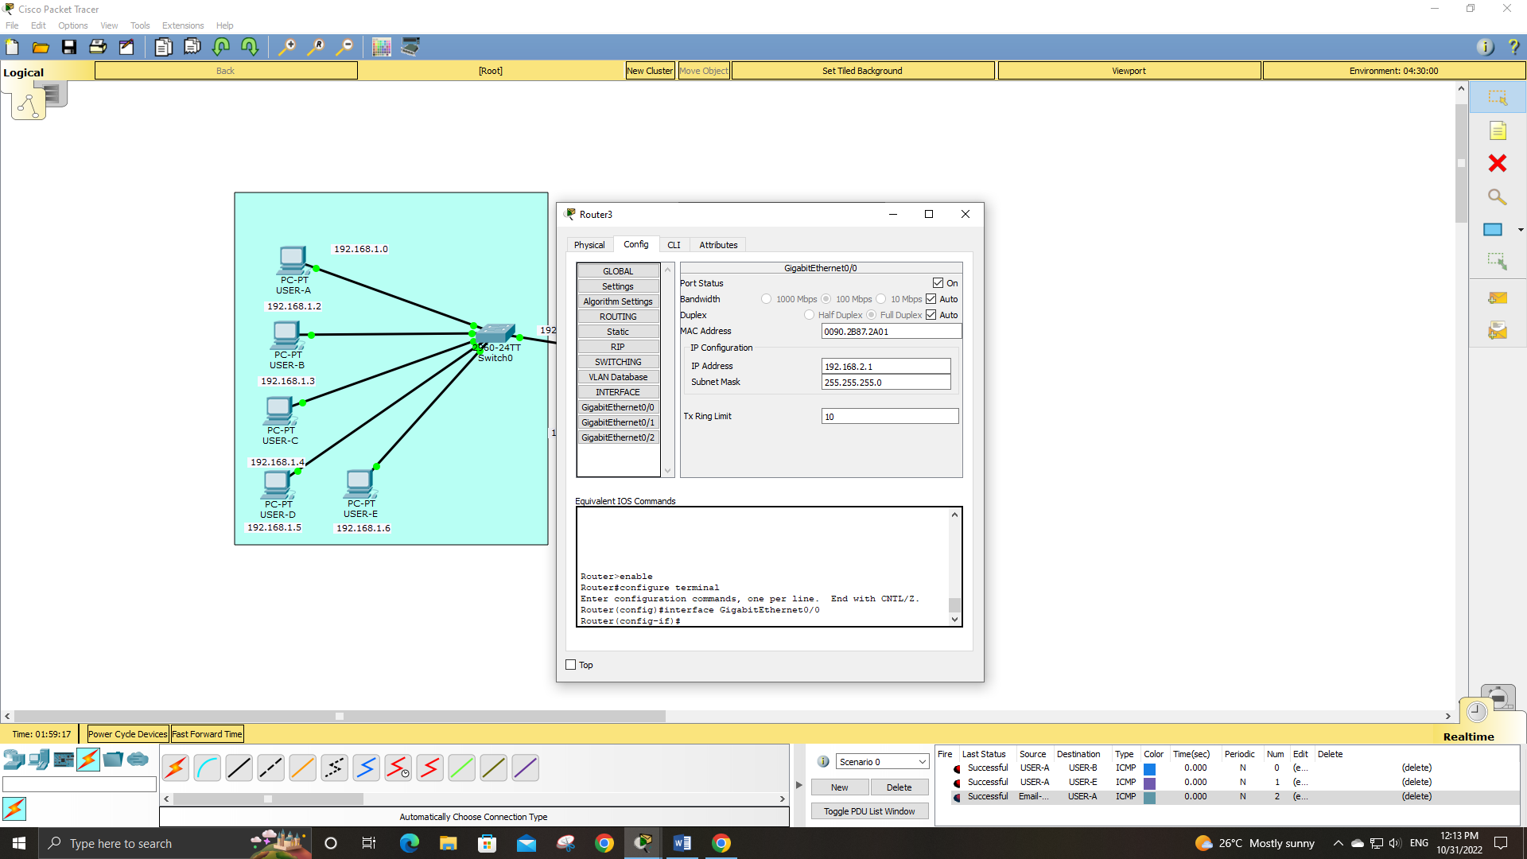

**EMAIL-SERVER AND DNS SERVER CONFIG:**

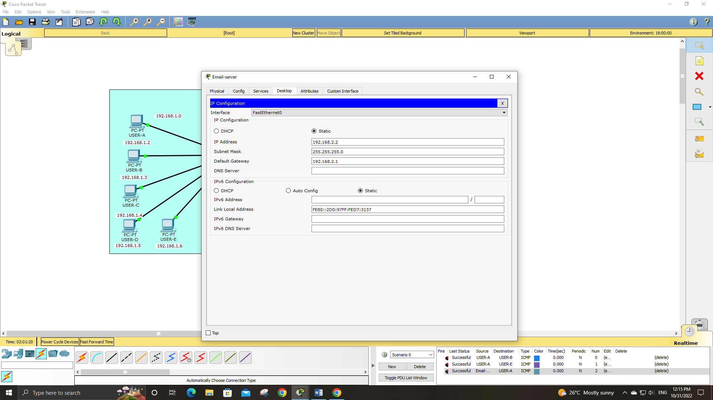

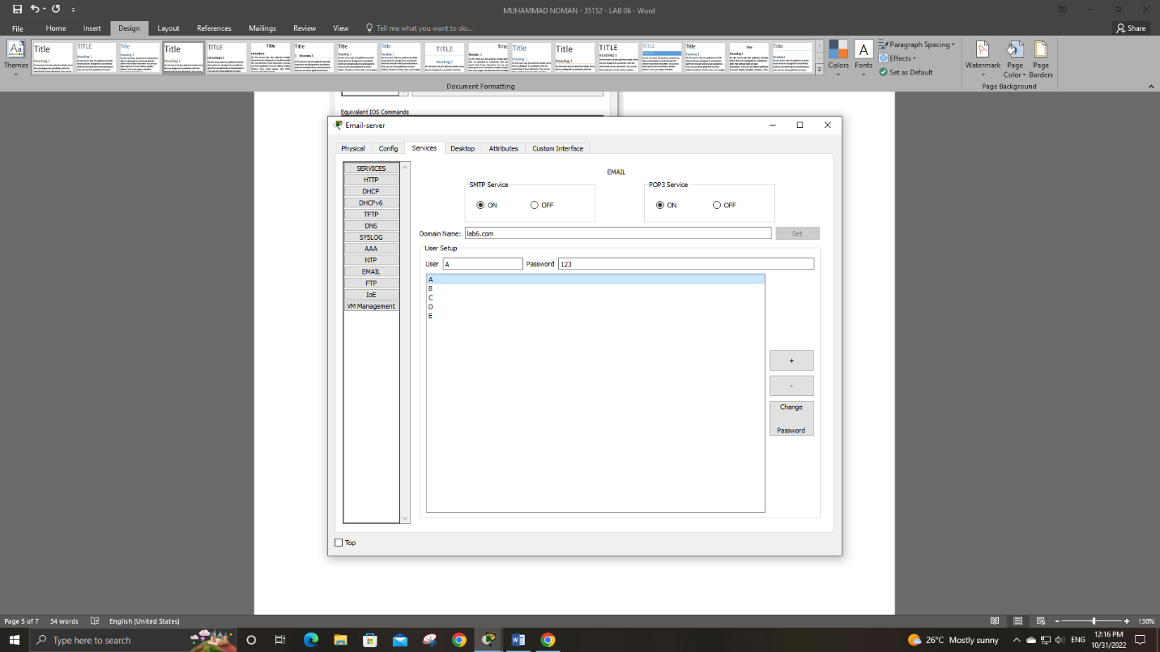

**DNS – SERVER:**

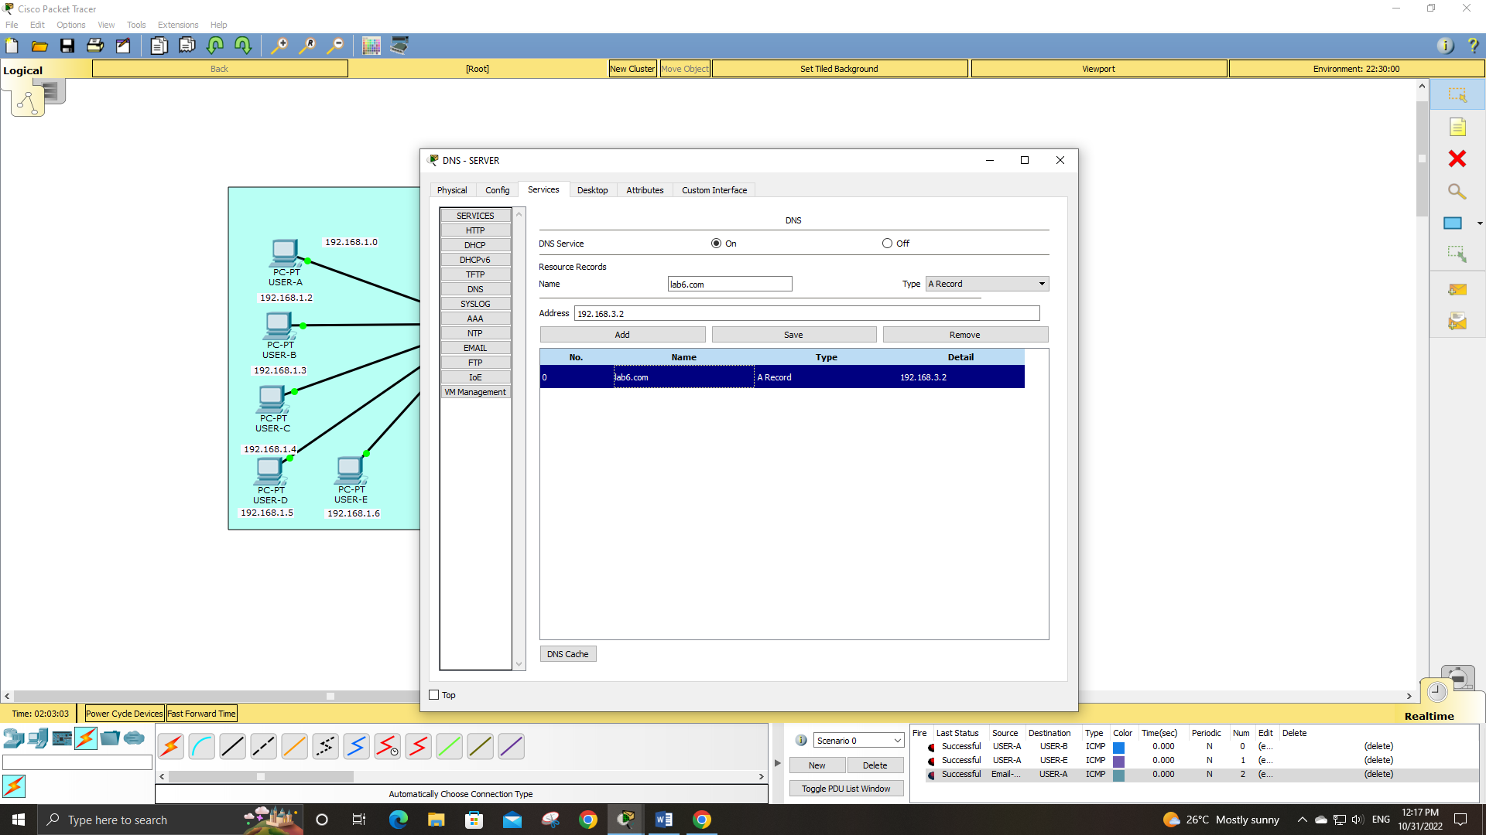

**PC-C TO – PC-D:**

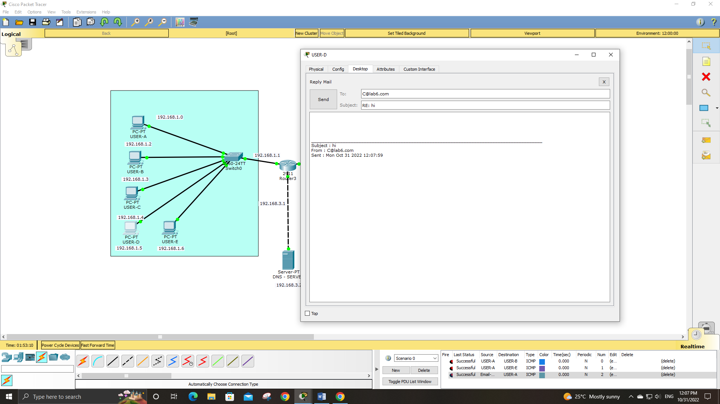**Reply:**

**Compose:**

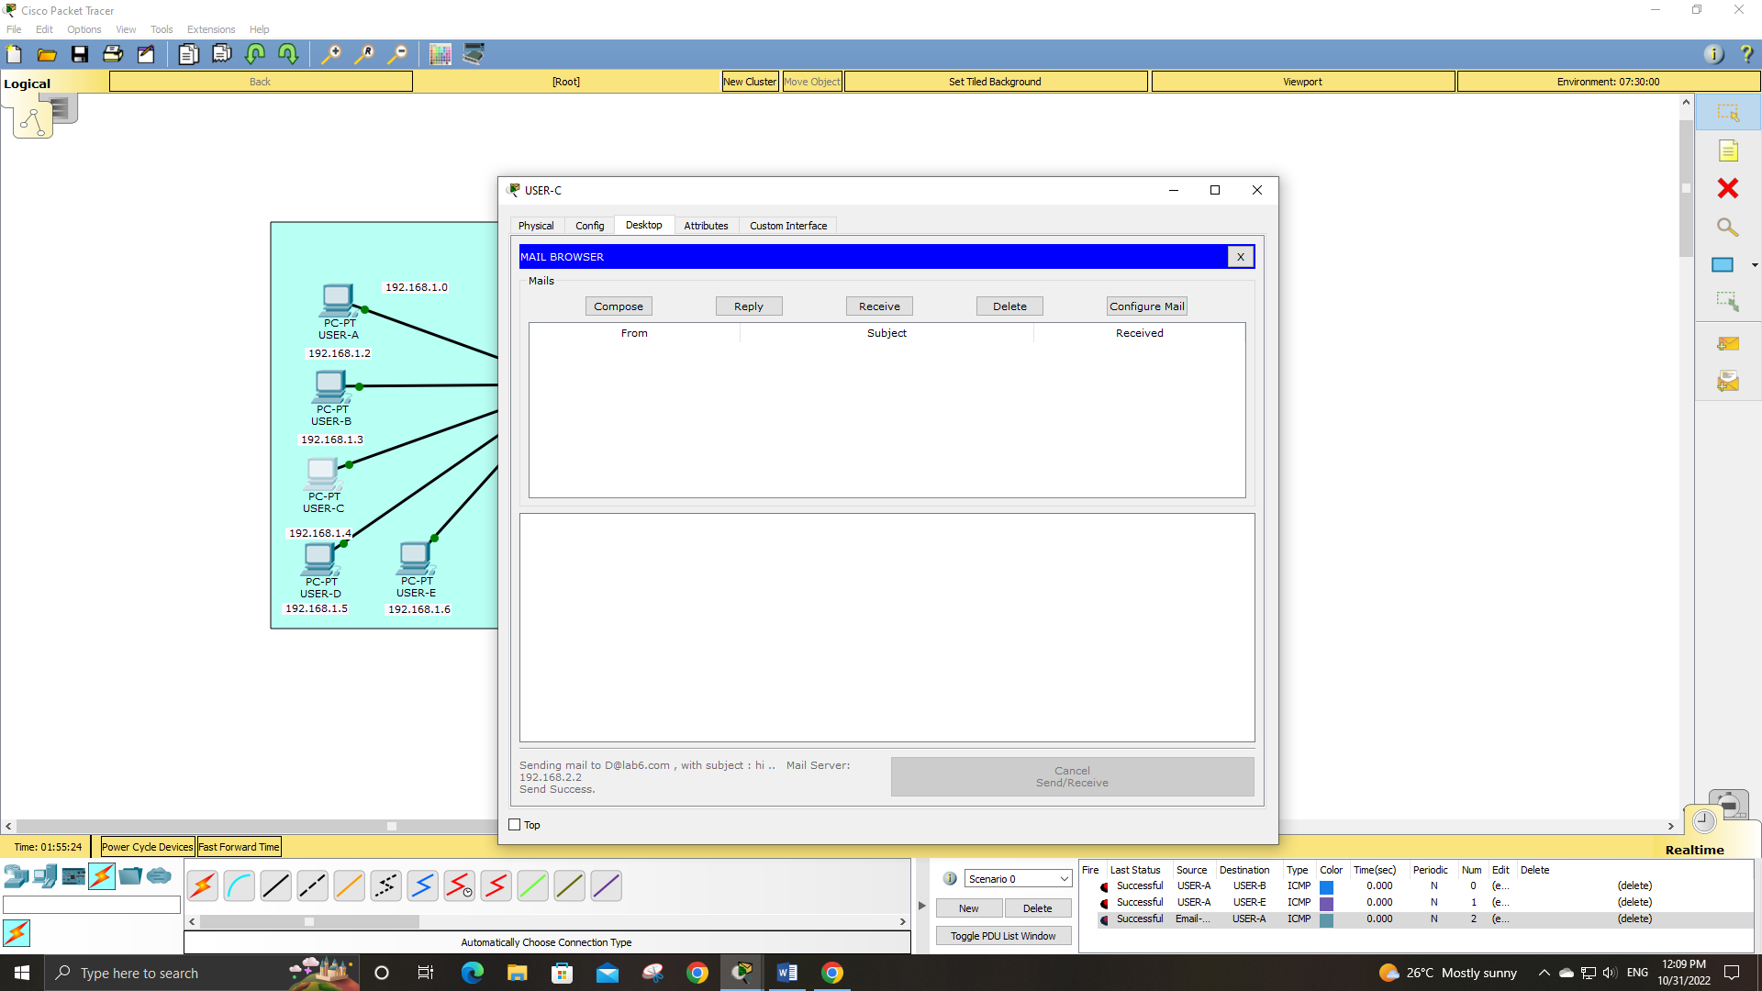

**Reply:**

